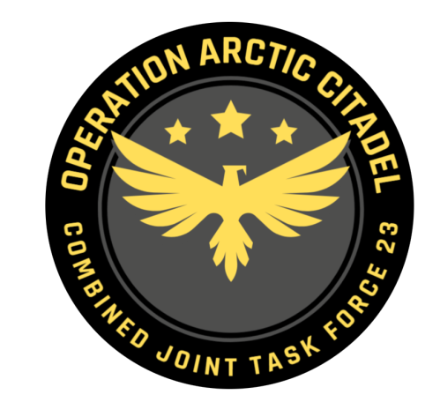

Joint Force Commander CJTF-23

DIRECTION AND GUIDANCE

D1

This document covers the friendly situation from D0 and provides CJTF-23 guidance to the entire force for D1.

**Reference CombatFlite**: <https://132nd-vwing.github.io/OPAC-Brief/SITUATION/Friendly%20Situation.cf>

# SITUATION

## General situation

Road to war according to introduction brief: [Operation Arctic Citadel Introduction Brief](https://132nd-vwing.github.io/OPAC-Brief/SITUATION/132nd%20OP%20ARCTIC%20CITADEL%20Introduction%20Brief.pdf)

D0: September 20th 2011:

JFACC[1] initiated intelligence gathering related to the situation, and completed phase 1 (Deployment) into theater. LCC[2] started deployment of IV Corps into Finland and are continuing force buildup.

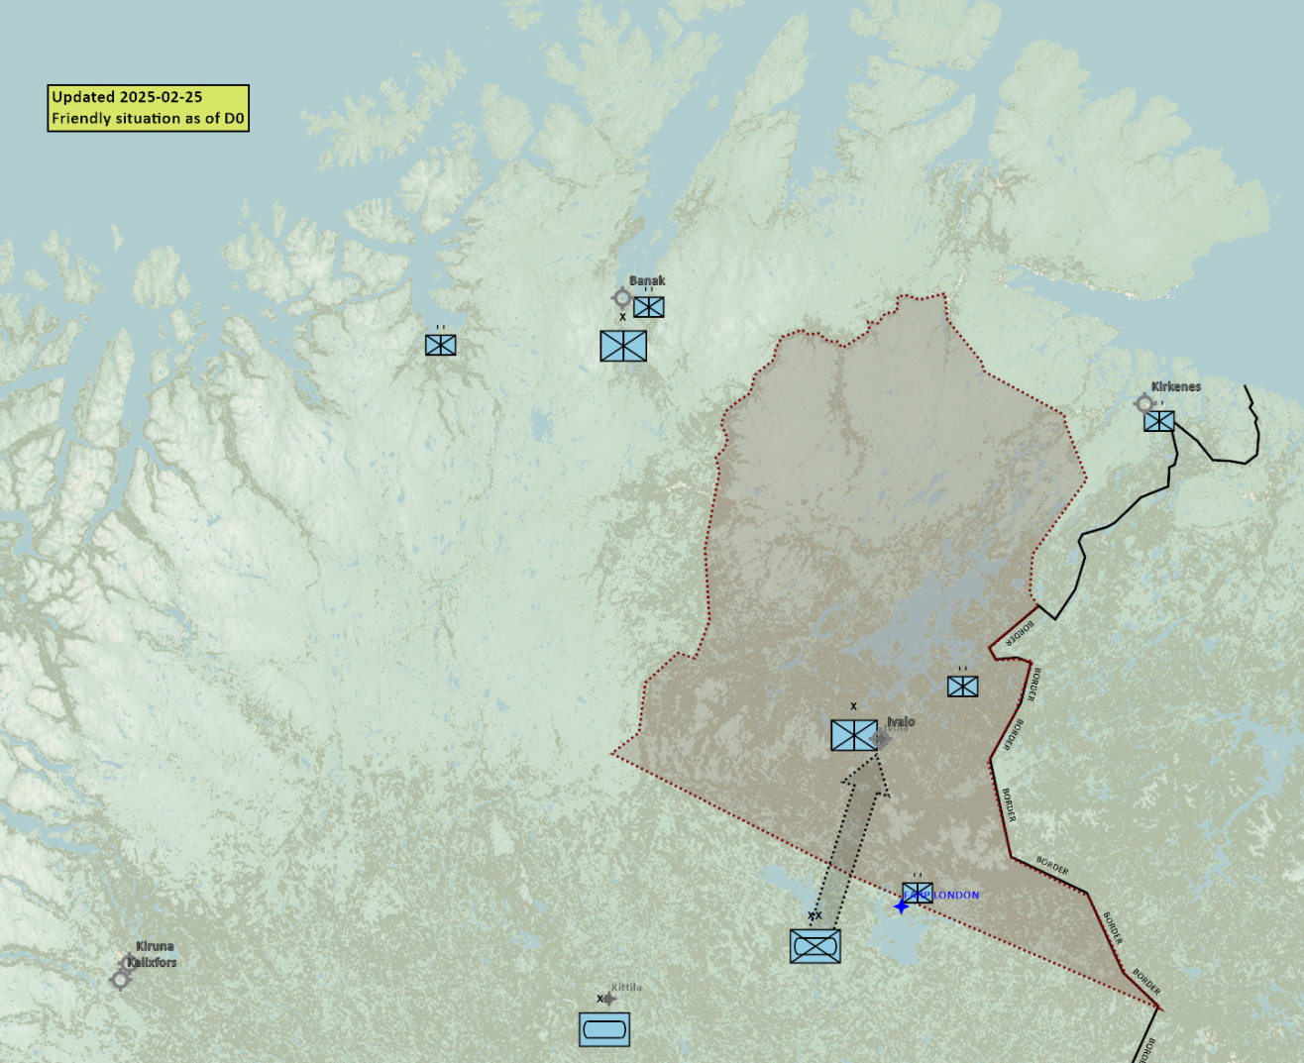

## Friendly situation

### Land Component Command (LCC)

#### IV Corps

##### 55th Armor Division (Abrahams and Challenger 2 tanks)

Currently in reserve located around Kittila.

##### 56th Mechanized Division (M2A2 Bradley, LAV-25 and Humwee’s)

Moving into contested area and aim to secure IVALO by the end of D1.

#### Finnish local forces

* The Finnish 33rd Brigade (M-113s)
* First BN – located IVO IVALO securing IVALO and the border.
* Second BN- located IVO FARP LONDON FARP

#### Norwegian local forces

* The Norwegian 44th Brigade (M-113s, Leopard and Bradley)
* First BN (Bradley IFV) – Located IVO Kirkenes
* Second BN (M113 APC) – Located IVO Banak
* Third BN (Leopard MBT – Located IVO Alta

### Maritime Component Command (MCC)

* CSG Continues workup SOUTH of Bodø.

### Special Operations Component Command (SOCC)

* SOF teams are standing by to support with reconnaissance as required.
* SOF teams are also on standby to conduct counter terrorism missions and counter insurgency operations.

# Reported Battle Damage Assessment

## IV Corps Northern Sector

* NSTR

## Finnish local forces.

* NSTR

## Norwegian local forces.

* NSTR

# Logistical situation

Available ordnance: <https://132nd-vwing.github.io/OPAC-Brief/MISSION%20INFORMATION/OPAC%20Ordnance.pdf>

# Direction and Guidance

## LCC:

* Continue operation to secure contested area in Finland by D2.

## MCC:

* Continue force buildup and move Carrier Strike Group into the area by D2.

## JFACC:

* Apportionment[3]
  + Per JFACC priorities
* JFACC have now completed phase 1 Deployment, and are now from D1 in phase 2 Deter.
* Priority of effort is to deter Notia from conducting an attack against Finland.
* Be prepared for a swift transition into phase 3a Defend IF Notia commences an attack on Finland on short notice[4]
  + Have a plan for transition to defense for all missions.
  + For strikes against IADS in Notia during initial phase of 3a (before next ATO days target meeting), ALR HIGH is approved from JFC.
* Phase 3b planning:
  + Start preparing a plan how to execute phase 3b if the situation needs it.
* Recommend to JFC changes in diplomatic status for any country during target meeting.
* Request to JFC ordnance if additional ordnance are needed during the target meeting.
* Recommend to JFC location of Carrier Strike Group during target meeting.

## VIS:

* Support JFACC with planning and execution of campaign.
  + Be prepared to support JFACC with phase 3b planning
* Recommend to JFC changes in diplomatic status for any country during target meeting.

## Diplomatic situation

* Notia is declared as adversary
* Kambiland is declared as neutral
* Xilong is declared as neutral
* DUSS is declared as neutral
* The Iron Resolve is declared as enemy
* The Dawn’s Vengeance is declared as adversary

Only units declared as enemy can and should be engaged by CJTF forces.

**Definitions:**

Enemy: is actively opposed or hostile to CJTF and friendly forces.

Adversary: opponent in a contest, conflict, or dispute toward CJTF and friendly forces.

Neutral: not supporting or helping either side in a conflict, disagreement, etc.; impartial.

1. Joint Force Air Component Commander – Commander of all air forces (player volunteers)
2. Land Component Commander – Commander of all land forces
3. Air apportionment is the determination and assignment of the total expected effort by percentage and/or priority that should be devoted to the various air operations and/or geographic areas for a given period of time.
4. During ATO day, during event